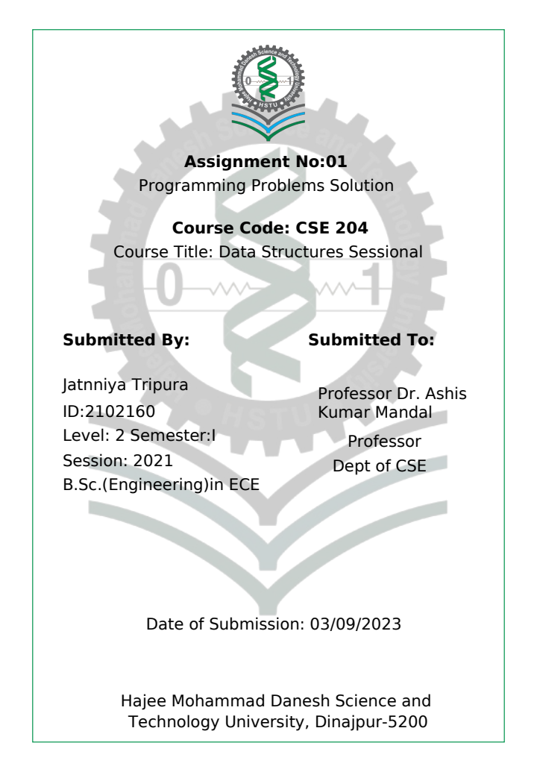

Programming Problems:

Question:1: Write a program that finds the prime numbers using sieve method.
Code:
#include <stdio.h>
int main() {
int n;
printf("Enter the range:");
scanf("%d",&n);
int array[n];
for(int i=2;i<=n;i++)
{
array[i]=-1;
printf("%d\t",i);
}
for(int i=2;i<=n;i++)
{
if(array[i]==-1)
{
for(int j=2;j*i<=n;j++)
{
array[j*i]=0;
}
}
}

for(int i=2;i<=n;i++)
{
if(array[i]==-1)
{
printf("%d\t",i);

}
}

return 0;
}
Output:
Question:02: Write a program that finds the largest and smallest elements in an array.
Code:

#include <stdio.h>
int main() {
int n;
printf("Enter the size of array:\t");
scanf("%d",&n);
int array[n];
printf("Enter the array element :\t");
for(int i=0;i<n;i++)
{
scanf("%d",&array[i]);
}
int max=array[0],min=array[0],i;
for( i=0;i<n;i++)
{
if(max<array[i])
{
max=array[i];
}
if(min>array[i])
{
min=array[i];
}

}
printf(" The Max number is :%d\n The Min number is :%d\n",max,min);
return 0;
}
Output:
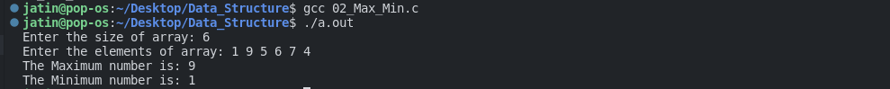

Question:03:An array A Containing N elements is given. Write a program that captures the sum of array elements.
Code:
#include<stdio.h>
int main()
{
int n,sum=0;
printf("Enter the size of array: ");
scanf("%d",&n);
int array[n];
printf("Enter the elements of array: ");
for(int i=0;i<n;i++)
{
scanf("%d",&array[i]);
}
for(int i=0;i<n;i++)
{
sum+=array[i];
}
printf("The sum of elements of array is: %d\n",sum);
}

Output:
Question:04: Write a program to find whether the array of integers contains a duplicate number.
Code:
#include<stdio.h>
int main()
{
int n,index=-1;
printf("Enter the size of array: ");
scanf("%d",&n);
int array[n];
printf("Enter the elements of array: ");
for(int i=0;i<n;i++)
{
scanf("%d",&array[i]);
}

for(int i=0;i<n;i++)
{
for(int j=i+1;j<n;j++)
{
if(array[i]==array[j])
{
printf("The duplicate number is :- %d\n",array[i]);
index=1;
}

}

}
if(index==-1)
printf("Element not found");

return 0;
}
Output:

Question:05: Write a program to insert a number at a given location in an array
Code:
#include<stdio.h>
int main()
{
int n;
printf("Enter the size of array: ");
scanf("%d",&n);
int array[n+1];
printf("Enter the elements of array: ");
for(int i=0;i<n;i++)
{
scanf("%d",&array[i]);
}
int pos,element;
printf("Enter the position where you want to insert the element: ");
scanf("%d",&pos);
printf("Enter the element you want to insert: ");
scanf("%d",&element);

for(int i=n;i>pos;i--)
{
array[i]=array[i-1];
}
array[pos]=element;
for(int i=0; i<n+1; i++)
{
printf("%d\t",array[i]);

}
return 0;
}
Output:
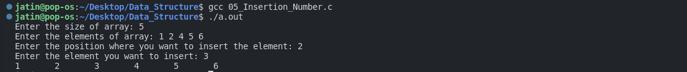

Question:06:Write a program to delete a number from a given location in an array
Code:
#include<stdio.h>
int main()
{
int n;
printf("Enter the size of array:");
scanf("%d",&n);
int array[n];
printf("Enter the element of array:");
for(int i=0;i<n;i++)
{
scanf("%d",&array[i]);
}
int pos;
printf("Enter the position:");
scanf("%d",&pos);
for(int i=pos;i<n;i++)
{
array[i]=array[i+1];
}
for(int i=0; i<n-1; i++)
{
printf("%d\t",array[i]);
}
return 0;

}
Output:

Question:07: Write a program to merge two sorted arrays

Code:
#include <stdio.h>

void merge(int a[], int m, int b[], int n, int r[]);

int main(void)
{
int a1[] = {1,3,5,7,9};
int a2[] = {2,4,5,6,8};
int r[10];

merge(a1, 5, a2, 5, r);

for (int i = 0; i < 10; i++)
printf(" %d\t ", r[i]);
printf("\n");
return 0;
}
void merge(int a[], int m, int b[], int n, int r[])
{
int i = 0, j = 0, k = 0;

while (i < m && j < n)
{
if (a[i] < b[j])
{
r[k] = a[i];
k++;
i++;
}
else
{
r[k] = b[j];
k++;
j++;
}
}
while (i < m)
{
r[k] = a[i];
k++;
i++;
}

while (j < n)
{
r[k] = b[i];
k++;
j++;
}

}
Output:

8.(a):-Bubble Sort: Write programs for implementing the following sorting methods to arrange a list of integers/strings in ascending/descending order:

Code:
#include<stdio.h>
int main() {
int n;
printf("Enter the size of array: ");
scanf("%d", & n);

int array[n];
printf("Enter the array element: ");
for (int i = 0; i < n; i++) {
scanf("%d", & array[i]);
}

for (int i = 0; i < n; i++) {
for (int j = 0; j < n - i - 1; j++) {
if (array[j] > array[j + 1]) {
int temp = array[j];
array[j] = array[j + 1];
array[j + 1] = temp;
}
}
}

for (int i = 0; i < n; i++) {
printf("%d ", array[i]);
}

printf("\n");
}
Output:

Question:9: Write programs for search an element from a list of integers/strings
a) Liner Search
Code:
#include<stdio.h>
int main()
{
int n,index=-1;
printf("Enter the size of array: ");
scanf("%d",&n);
int array[n];
printf("Enter the elements of array: ");
for(int i=0;i<n;i++)
{
scanf("%d",&array[i]);
}
int search;
printf("Enter the element to be searched: ");
scanf("%d",&search);
for(int i=0;i<n;i++)
{
if(array[i]==search){
printf(" The location of element:%d\n",i);
printf("The element is:%d\n",array[i]);
index=1;
}
}
if(index==-1)
printf("Element not found");

return 0;
}
Output:
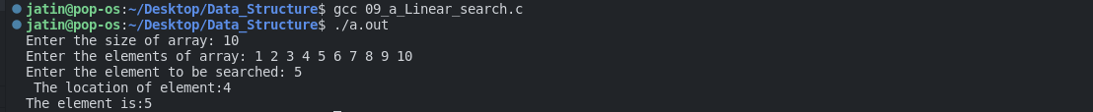

b) Binary Search
Code:
#include<stdio.h>
int main()
{
int i,n,element,begin,end;
printf("Enter the size of array:");
scanf("%d",&n);
int array[n];
printf("Enter the array of element:");
for( i=0;i<n;i++)
{
scanf("%d",&array[i]);
}
printf("Enter the search of array element:");
scanf("%d",&element);
begin = 0;
end = n-1;
int mid=(begin+end)/2;

while(begin<=end )
{
if(array[mid]<element)
end = mid+1;
else if (element==array[mid])
{
printf("The location is : %d\n",mid);
printf("The element is : %d\n",array[mid]);
break;
}
else
end = mid-1;
mid=(begin+end)/2;
}
if(begin>end)
printf("Not found data");

return 0;
}
Output:
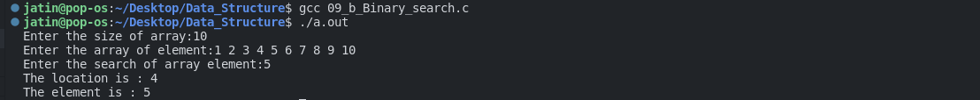

Question:10: Write a program to read and display a matrix.
Code:
#include <stdio.h>
int main()
{
int arr1[3][3],i,j;
printf("Input elements in the matrix :\n");
for(i=0;i<3;i++)
{
for(j=0;j<3;j++)
{
printf("element - [%d],[%d] : ",i,j);
scanf("%d",&arr1[i][j]);
}
}

printf("\nThe matrix is : \n");
for(i=0;i<3;i++)
{
printf("\n");
for(j=0;j<3;j++)
printf("%d\t",arr1[i][j]);
}
printf("\n\n");
}

Output:
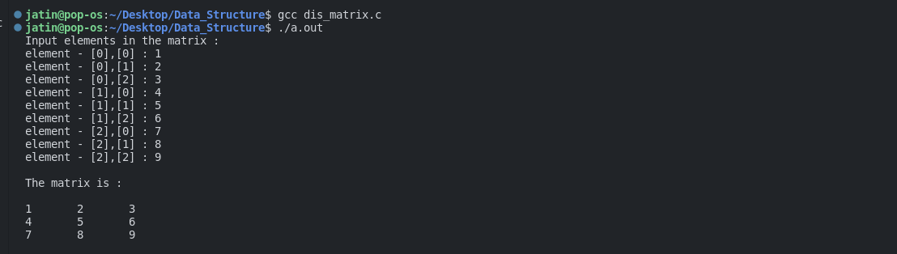
Question:11: Write a program to add and multiply two matrices.
Code:
#include<stdio.h>
int main()
{
int a[3][3], b[3][3], c[3][3]={0}, d[3][3]={0};
int i,j,k,m,n,p,q;
printf("Enter no. of rows and columns in matrix A: ");
scanf("%d%d",&m,&n);
printf("Enter no. of rows and columns in matrix B: ");
scanf("%d%d",&p,&q);
if(m!=p || n!=q)
{
printf("Matrix Addition is not possible");
return;
}
else if(n!=p)
{
printf("Matrix Multiplication is not possible");
return;
}
else
{
printf("Enter elements of matrix A: ");
for(i=0;i<m;i++)
for(j=0;j<n;j++)
scanf("%d", &a[i][j]);
printf("Enter elements of matrix B: ");
for(i=0;i<p;i++)
for(j=0;j<q;j++)
scanf("%d", &b[i][j]);
//Matrix Addition
for(i=0;i<m;i++)
for(j=0;j<n;j++)
c[i][j] = a[i][j] + b[i][j];
printf("\nResult of Matirx Addition:\n");
for(i=0;i<m;i++)
{
for(j=0;j<n;j++)
printf("%d ", c[i][j]);
printf("\n");
}
//Matrix Multiplication
for(i=0;i<m;i++)
for(j=0;j<q;j++)
for(k=0;k<p;k++)
d[i][j] += a[i][k]*b[k][j];
printf("\nResult of Matirx Multiplication:\n");
for(i=0;i<m;i++)
{
for(j=0;j<q;j++)
printf("%d ", d[i][j]);
printf("\n");
}
}
return 0;
}
Output:
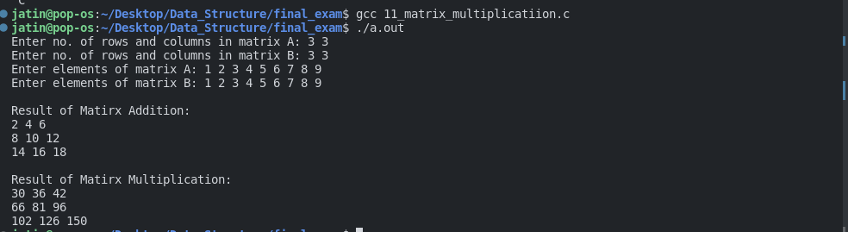

Question:12: Write a program that takes a matrix A and finds its transpose AT and displays it.
Code:
#include <stdio.h>

int main()

{
int arr1[50][50],brr1[50][50],i,j,r,c;

printf("\nInput the rows and columns of the matrix : ");
scanf("%d %d",&r,&c);

printf("Input elements in the first matrix :\n");
for(i=0;i<r;i++)
{
for(j=0;j<c;j++)
{
printf("element - [%d],[%d] : ",i,j);
scanf("%d",&arr1[i][j]);
}
}

printf("\nThe matrix is :\n");
for(i=0;i<r;i++)
{
printf("\n");
for(j=0;j<c;j++)
printf("%d\t",arr1[i][j]);
}

for(i=0;i<r;i++)
{
for(j=0;j<c;j++)
{
brr1[j][i]=arr1[i][j];
}
}

printf("\n\nThe transpose of a matrix is : ");
for(i=0;i<c;i++){
printf("\n");
for(j=0;j<r;j++){
printf("%d\t",brr1[i][j]);
}
}
printf("\n\n");
}
Output:
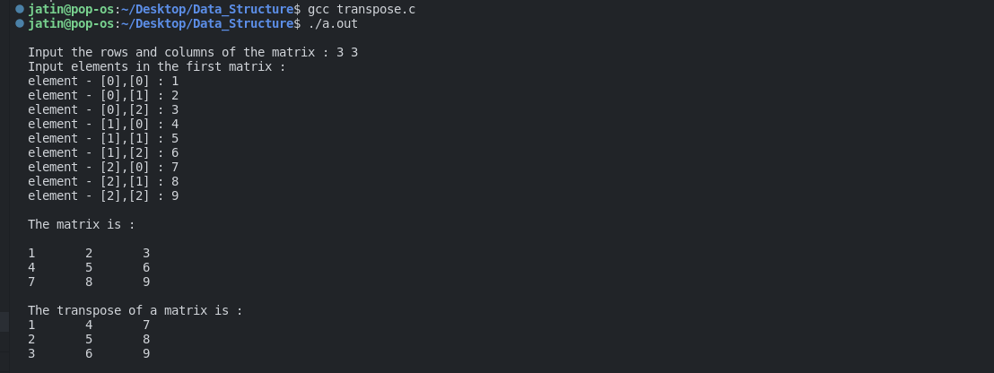

Question:13: Write a program that computes the sum of diagonal elements of a square matrix.
Code:
#include<stdio.h>
int main()
{
int i, j, matrix[10][10], row, col;
int sum = 0;

printf("\nEnter the number of Rows : ");
scanf("%d", &row);

printf("\nEnter the number of Columns : ");
scanf("%d", &col);
for (i = 0; i < row; i++)
{
for (j = 0; j < col; j++)
{
printf("\nEnter the Element a[%d][%d] : ", i, j);
scanf("%d", &matrix[i][j]);
}
}
for (i = 0; i < row; i++)
{
for (j = 0; j < col; j++)
{
if (i == j)
sum = sum + matrix[i][j];
}
}
printf("\nSum of Diagonal Elements in Matrix is: %d", sum);
return 0;
}
Output:
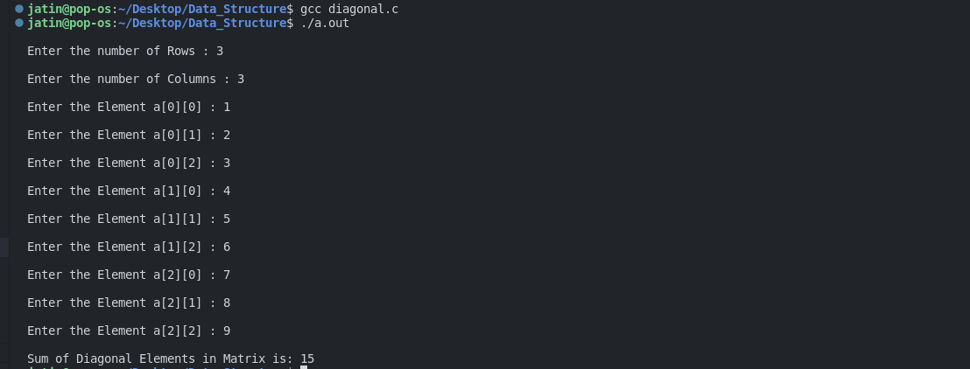
Question:14: Write a program to find the length of a string.
Code:
#include <stdio.h>
int main() {
char s[] = "Programming";
int i;

for (i = 0; s[i] != '\0'; ++i);

printf("Length of the string: %d", i);
return 0;
}
Output:
Question:15: Write a program to concatenate two strings.
Code:
#include<stdio.h>
#include<string.h>
int main()
{

char name[50]="programing ";
char title[]=" is awesome";
int i=0,length=0,j=0;
while(name[i]!='\0')
{
i++;
length++;
}
while(title[j]!='\0')
{
name[length+j]=title[j];
j++;
}
puts(name);
}

Output:
Question:16: Write a program to compare two strings
Code:
#include<stdio.h>
#include <string.h>
int main()
{
char s1[1000],s2[1000];
int i,count=0;

printf("Enter string1: ");
gets(s1);
printf("Enter string2: ");
gets(s2);
if(strlen(s1)==strlen(s2))
{
for(i=0;s2[i]!='\0';i++)
{
if(s1[i]==s2[i])
count++;
}
if(count==i)
printf("strings are equal");
else
printf("strings are not equal");
}
else
printf("strings are not equal\n");
return 0;
}
Output:
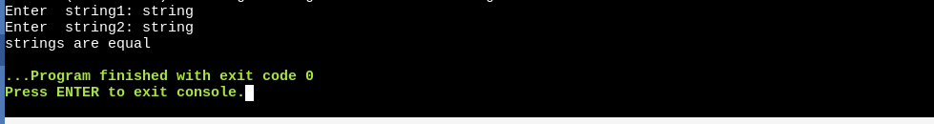

Question:17: Write a program to reverse a given string.
Code:
#include <stdio.h>
#include<string.h>
int main()
{
char string[100], reverse[100];
int i = 0, j=0, length;
printf("Input a string:");
gets(string);
while (string[i] != '\0')
i++;

length = i - 1;
while(length>=0) {
reverse[j] = string[length];
j++;
length--;
}

reverse[length] = '\0';

printf("The reverse string is:%s\n", reverse);

return 0;
}
Output:
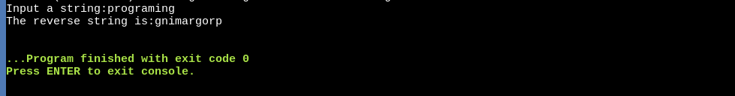
Question:18: Write a program to extract a substring from a given string.
Code:
#include <stdio.h>

int main()
{
char string[100], sub[100];
int position, length, i = 0;

printf("Input a string:");
gets(string);

printf("Enter the position and length of substring:");
scanf("%d%d", &position, &length);

while (i < length) {
sub[i] = string[position+i-1];
i++;
}
sub[i] = '\0';

printf("The substring is:%s", sub);

return 0;
}
Output:

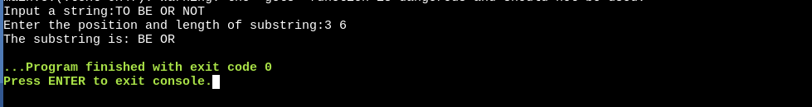
Question:19: Write a program to insert a string in the main text.
Code:
#include <stdio.h>
#include <string.h>
int main()
{
char S1[50], S2[15];
int index, i, l1, l2;
printf("Enter String : ");
gets(S1);
printf("Enter Substring : ");
gets(S2);
printf("Enter Index : ");
scanf("%d", &index);
l1 = strlen(S1);
l2 = strlen(S2);
if(index > l1)
{
printf("Invalid Index");
exit(0);
}
for(i = l1;i >= index; i--)
S1[i + l2] = S1[i];
for(i = 0;i < l2; i++)
S1[index + i] = S2[i];
printf("\nAfter Insertion : %s", S1);
}
Output:
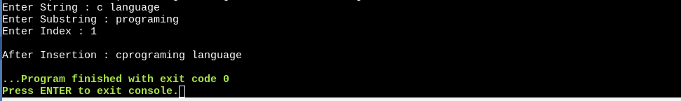
Question:20: Write a program to delete every occurrence of a pattern from a text.
Code:
#include<stdio.h>
#include<string.h>
void main()
{
char str[20];
int i, n, length, pos;
printf("Enter the string:");
gets(str);
printf("Enter the position :");
scanf("%d", &pos);
printf("Enter the length:");
scanf("%d", &n);
length = strlen(str);
for(i = pos + n; i < length; i++)
{
str[i - n] = str[i];
}
str[i - n] = '\0';
printf("The string is: %s", str);
}
Output:
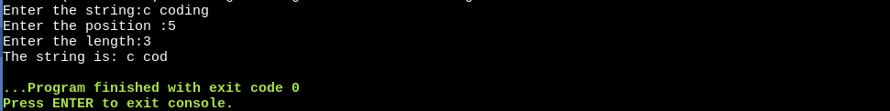

Question:21: Write a program to replace a pattern with another pattern in the text.
Code:
#include<stdio.h>
#include<string.h>
int main() {
char str[256] = " The c problem", substr[128] = "problem", replace[128] = "programe ", output[256];
int i = 0, j = 0, flag = 0, start = 0;

str[strlen(str) - 1] = '\0';
substr[strlen(substr) - 1] = '\0';
replace[strlen(replace) - 1] = '\0';

while (str[i] != '\0')
{
if (str[i] == substr[j])
{
if (!flag)
start = i;
j++;
if (substr[j] == '\0')
break;
flag = 1;
}
else
{
flag = start = j = 0;
}
i++;
}
if (substr[j] == '\0' && flag)
{
for (i = 0; i < start; i++)
output[i] = str[i];

for (j = 0; j < strlen(replace); j++)
{
output[i] = replace[j];
i++;
}

for (j = start + strlen(substr); j < strlen(str); j++)
{
output[i] = str[j];
i++;
}

output[i] = '\0';
printf("Output: %s\n", output);
} else {
printf("%s is not a substring of %s\n", substr, str);
}
return 0;
}
Output:
Question:22:Write a program to develop the first pattern matching algorithm (Brute Force based).
Code:
#include <stdio.h>
#include <string.h>
int main()
{
char text[20],pat[8];
int a,b,count=0;
printf("Enter the string : ");
gets(text);
printf("Enter the pattern to find : ");
gets(pat);

a = strlen(pat);
b = strlen(text);

for (int i = 0; i <= b - a; i++) {
int j;

for (j = 0; j < a; j++)
if (text[i + j] != pat[j])
break;

if (j == a)
printf("Pattern found at position %d \n", i+1);
count=1;
}
if(count==0)
printf("Pattern not found");
return 0;
}
Output:
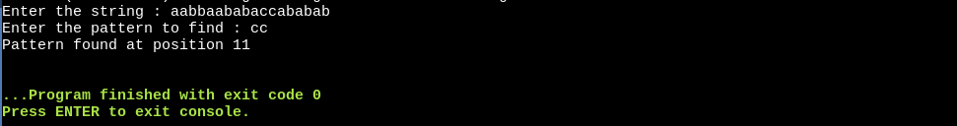
Question:24: Write a program that uses functions to perform the following operations on singly linked
list:
a) Creation
b) Insertion
c) Deletion
d) Traversal
Code:
#include<stdio.h>
#include<stdlib.h>

struct node{
int data;
struct node *next;
};
// Insert a node in begin funtion

struct node *add_begin(struct node *head,int data){
struct node *ptr=(struct node *)malloc(sizeof(struct node));
ptr->data=data;
ptr->next=head;
return ptr;
};
// Add node in index function
struct node *add_index(struct node *head,int data,int index){
struct node *ptr=(struct node *)malloc(sizeof(struct node));
struct node *p=head;
int i=0;
while(i!=index-1)
{
p=p->next;
i++;
}
ptr->data=data;
ptr->next=p->next;
p->next=ptr;
return head;
};

// Insert add end function
struct node *add_end(struct node *head,int data){
struct node *ptr=(struct node*)malloc(sizeof(struct node));
ptr->data=data;
struct node *p=head;
while(p->next!=NULL)
{
p=p->next;
}
p->next=ptr;
ptr->next=NULL;
return head;
};
// first node delete function
struct node *delete_at_begin(struct node *head){
struct node*ptr=head;
head=head->next;
free(ptr);
return head;
};

// delete index at node
struct node *delete_at_index(struct node *head , int index){
struct node*p=head;
struct node*q=head->next;
for(int i=0;i<index-1;i++)
{
p=p->next;
q=q->next;
}
p->next=q->next;
free(q);
return head;
};

struct node *delete_at_end(struct node *head ){
struct node*p=head;
struct node*q=head->next;
while(q->next !=NULL)
{
p=p->next;
q=q->next;
}
p->next=NULL;
free(q);
return head;
};

// Traverse function
void print(struct node *ptr)
{
while(ptr != NULL)
{
printf(" Element: %d\n",ptr->data);
ptr=ptr->next;
}
};
int main()
{
//create a node

struct node *head=(struct node *)malloc(sizeof(struct node));
struct node *first=(struct node *)malloc(sizeof(struct node));
struct node *second=(struct node *)malloc(sizeof(struct node));
head->data=30;
head->next=first;
first->data=40;
first->next=second;
second->data=50;
second->next=NULL;
printf("Traverse the node:\n");
print(head);
printf("\n");
//Begin add function calling
head=add_begin(head,20);
printf("After add in begin the node:\n");
print(head);
printf("\n");
// Index add function callng
head=add_index(head,35,2);
printf("After add in the node at 2 no index:\n");
print(head);
printf("\n");
// Add end function call
head=add_end(head,60);
printf("After add at end:\n");
print(head);
printf("\n");
// delete function calling
head=delete_at_begin(head);
printf("After delete at first node:\n");
print(head);
printf("\n");

//delete index at node functiion calling
head=delete_at_index(head,3);
printf("After delete the 3 no index:\n");
print(head);
printf("\n");
// delete at end node functiion calling
head=delete_at_end(head);
printf("After the delete at last node :\n");
print(head);
printf("\n");

return 0;
}
Output:
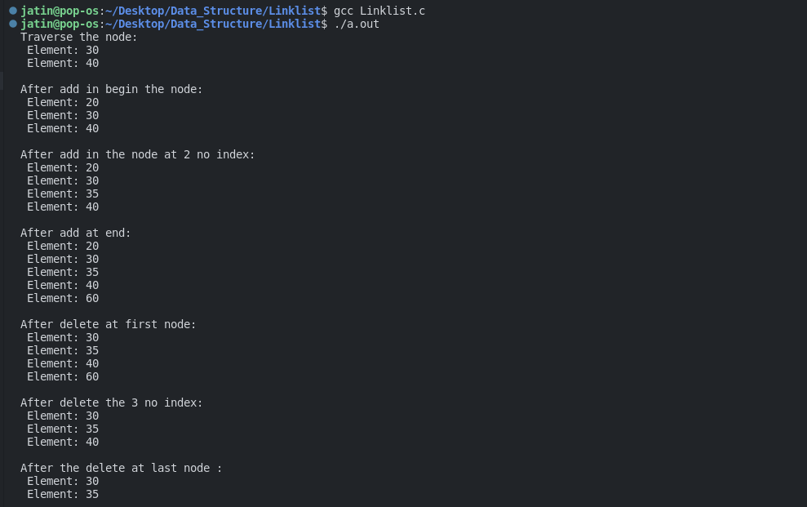
Question:25: Write a program to create a circular linked list. Perform insertion and deletion at the beginning and end of the list.

Question:26: Write programs that uses stack operations to convert a given infix expression into its postfix equivalent. Implement the stack using an array.
Code:
include<ctype.h>
#include<stdio.h>
#
char stack[100];
int top = -1;

void push(char x)
{
stack[++top] = x;
}

char pop()
{
if(top == -1)
return -1;
else
return stack[top--];
}

int priority(char x)
{
if(x == '(')
return 0;
if(x == '+' || x == '-')
return 1;
if(x == '*' || x == '/')
return 2;
return 0;
}

int main()
{
char exp[100];
char *e, x;
printf("Enter the expression : ");
scanf("%s",exp);
printf("\n");
e = exp;

while(*e != '\0')
{
if(isalnum(*e))
printf("%c ",*e);
else if(*e == '(')
push(*e);
else if(*e == ')')
{
while((x = pop()) != '(')
printf("%c ", x);
}
else
{
while(priority(stack[top]) >= priority(*e))
printf("%c ",pop());
push(*e);
}
e++;
}

while(top != -1)
{
printf("%c ",pop());
}return 0;
}
Output:
Question:27: Write a Program in C to Implement
a) Stacks using arrays
Code:

#include <stdio.h>
#define MAX 50
int top = -1;
int arr[MAX];

void push(int item){

if(top == MAX-1){
printf("Stack Overflow");
return;
}else{

arr[++top]=item;
printf("Push value is %d\n",item);
}
}

void pop(){

int val;

if(top == -1){
printf("Stack underflow");
return;
} else {
val = arr[top];
--top;
}

printf( "Pop value is %d\n",val);
}

int main()
{
int arr[MAX];

push(2);
push(4);
push(6);

pop();
pop();
pop();

}
Output:
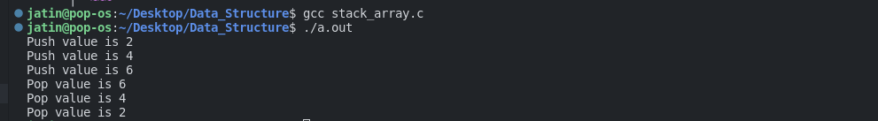
b) Stacks using linked list
Code:
#include <stdio.h>
#include <stdlib.h>
#define TRUE 1
#define FALSE 0

struct node
{
int data;
struct node *next;
};
typedef struct node node;

node *top;

void initialize()
{
top = NULL;
}

void push(int value)
{
node *tmp;
tmp = malloc(sizeof(node));
tmp -> data = value;
tmp -> next = top;
top = tmp;
}

int pop()
{
node *tmp;
int n;
tmp = top;
n = tmp->data;
top = top->next;
free(tmp);
return n;
}

int Top()
{
return top->data;
}

int isempty()
{
return top==NULL;
}

void display(node *head)
{
if(head == NULL)
{
printf("NULL\n");
}
else
{
printf("%d\n", head -> data);
display(head->next);
}
}

int main()
{
initialize();
push(10);
push(20);
push(30);
printf("The top is %d\n",Top());
pop();
printf("The top after pop is %d\n",Top());
display(top);
return 0;
}
Output:
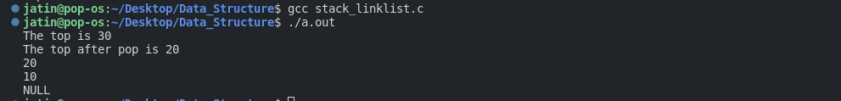
c) Queue using arrays
Code:
#include <stdio.h>
#define MAXSIZE 10

int queue[MAXSIZE];

int front = -1;
int rear = -1;
int size = -1;

int isempty()
{
return size<0;
}

int isfull()
{
return size == MAXSIZE;
}

void enqueue(int value)
{
if(size<MAXSIZE)
{
if(size<0)
{
queue[0] = value;
front = rear = 0;
size = 1;
}
else if(rear == MAXSIZE-1)
{
queue[0] = value;
rear = 0;
size++;
}
else
{
queue[rear+1] = value;
rear++;
size++;
}
}
else
{
printf("Queue is full\n");
}
}

int dequeue()
{
if(size<0)
{
printf("Queue is empty\n");
}
else
{
size--;
front++;
}
}

int Front()
{
return queue[front];
}

void display()
{
int i;
if(rear>=front)
{
for(i=front;i<=rear;i++)
{
printf("%d\n",queue[i]);
}
}
else
{
for(i=front;i<MAXSIZE;i++)
{
printf("%d\n",queue[i]);
}
for(i=0;i<=rear;i++)
{
printf("%d\n",queue[i]);
}
}
}

int main()
{

enqueue(10);
enqueue(20);
display();
dequeue();
printf("After dequeue\n");
display();
enqueue(50);
enqueue(60);

dequeue();
;
enqueue(110);
enqueue(120);
printf("After enqueue\n");
display();
return 0;
}
Output:

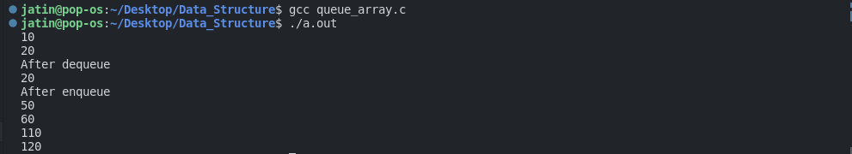
d) circular queue using arrays
Code:
#include <stdio.h>
#include <stdlib.h>
struct queue
{
int *items;
int maxsize;
int front;
int rear;
int size;
};
struct queue* newQueue(int size)
{
struct queue *pt = NULL;
pt = (struct queue*)malloc(sizeof(struct queue));

pt->items = (int*)malloc(size * sizeof(int));
pt->maxsize = size;
pt->front = 0;
pt->rear = -1;
pt->size = 0;

return pt;
}
int size(struct queue *pt) {
return pt->size;
}
int isEmpty(struct queue *pt) {
return !size(pt);
}
int front(struct queue *pt)
{
if (isEmpty(pt))
{
printf("Underflow\nProgram Terminated\n");
exit(EXIT_FAILURE);
}

return pt->items[pt->front];
}
void enqueue(struct queue *pt, int x)
{
if (size(pt) == pt->maxsize)
{
printf("Overflow\nProgram Terminated\n");
exit(EXIT_FAILURE);
}

printf("Inserting %d\t", x);

pt->rear = (pt->rear + 1) % pt->maxsize;
pt->items[pt->rear] = x;
pt->size++;

printf("front = %d, rear = %d\n", pt->front, pt->rear);
}
void dequeue(struct queue *pt)
{
if (isEmpty(pt))
{
printf("Underflow\nProgram Terminated\n");
exit(EXIT_FAILURE);
}

printf("Removing %d\t", front(pt));

pt->front = (pt->front + 1) % pt->maxsize;
pt->size--;

printf("front = %d, rear = %d\n", pt->front, pt->rear);
}

int main()
{
struct queue *pt = newQueue(5);

enqueue(pt, 1);
enqueue(pt, 2);
enqueue(pt, 3);
enqueue(pt, 4);

dequeue(pt);
dequeue(pt);
dequeue(pt);
dequeue(pt);

enqueue(pt, 5);
enqueue(pt, 6);

printf("size = %d\n", size(pt));

if (isEmpty(pt)) {
printf("The queue is empty");
}
else {
printf("The queue is not empty");
}

return 0;
}
Output:

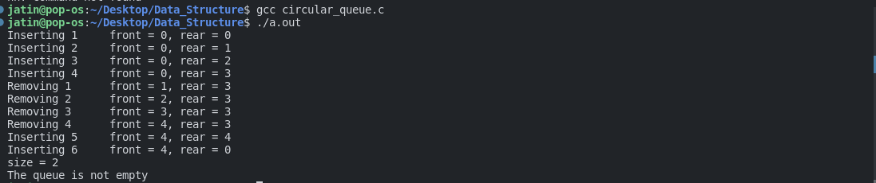
Question:30: Write a program to calculate the factorial of a given number.
Code:
#include<stdio.h>
int fact(int n);
int main(){
int n;
printf("Enter the factorial number:");
scanf("%d",&n);
int ans = fact(n);
printf("%d\n",ans);
return 0;
}
int fact( int n){
if(n==1){
return 1;
}
int result = n * fact(n-1);
return result;
}
Output:

Question:31: Write a program to print the Fibonacci series using recursion.

Code:
#include<stdio.h>
int main()
{
int frist=0,second=1,count=0,fibo,n;
printf("Enter the range:");
scanf("%d",&n);
while(count<n){
if(count<=1)
{
fibo=count;
}
else{
fibo=frist+second;
frist=second;
second=fibo;

}
printf("%d\t",fibo);
count ++;
}
printf("\n");
return 0;
}

Output:
Question:35: Write a program to create a binary search tree
Code:
#include <stdio.h>
#include <stdlib.h>

struct node {
int data;
struct node *right_child;
struct node *left_child;
};

//function to create a node
struct node* new_node(int x) {
struct node *temp;
temp = malloc(sizeof(struct node));
temp -> data = x;
temp -> left_child = NULL;
temp -> right_child = NULL;

return temp;
}

// searching operation
struct node* search(struct node * root, int x) {
if (root == NULL || root -> data == x)
return root;
else if (x > root -> data)
return search(root -> right_child, x);
else
return search(root -> left_child, x);
}

// insertion
struct node* insert(struct node * root, int x) {

if (root == NULL)
return new_node(x);
else if (x > root -> data)
root -> right_child = insert(root -> right_child, x);
else
root -> left_child = insert(root -> left_child, x);
return root;
}

//function to find the minimum value in a node
struct node* find_minimum(struct node * root) {
if (root == NULL)
return NULL;
else if (root -> left_child != NULL)
return find_minimum(root -> left_child);
return root;
}

// deletion
struct node* delete(struct node * root, int x) {

if (root == NULL)
return NULL;
if (x > root -> data)
root -> right_child = delete(root -> right_child, x);
else if (x < root -> data)
root -> left_child = delete(root -> left_child, x);
else {
//No Child node
if (root -> left_child == NULL && root -> right_child == NULL) {
free(root);
return NULL;
}

//One Child node
else if (root -> left_child == NULL || root -> right_child == NULL) {
struct node *temp;
if (root -> left_child == NULL)
temp = root -> right_child;
else
temp = root -> left_child;
free(root);
return temp;
}

//Two Children
else {
struct node *temp = find_minimum(root -> right_child);
root -> data = temp -> data;
root -> right_child = delete(root -> right_child, temp -> data);
}
}
return root;
}

// Inorder Traversal
void inorder(struct node *root) {
if (root != NULL)
{
inorder(root -> left_child);
printf(" %d ", root -> data);
inorder(root -> right_child);
}
}

int main() {
struct node *root;
root = new_node(20);
insert(root, 5);
insert(root, 1);
insert(root, 15);
insert(root, 9);
insert(root, 7);
insert(root, 12);
insert(root, 30);
insert(root, 25);
insert(root, 40);
insert(root, 45);
insert(root, 42);

inorder(root);
printf("\n");

root = delete(root, 1);

root = delete(root, 40);

root = delete(root, 45);

root = delete(root, 9);

inorder(root);
printf("\n");

return 0;
}
Output:

Question:36: Write a program to create a graph of n vertices using an adjacency list.
Code:
#include <stdio.h>
#include <stdlib.h>
#define N 6
struct Graph
{
struct Node* head[N];
};
struct Node
{
int dest;
struct Node* next;
};
struct Edge {
int src, dest;
};
struct Graph* createGraph(struct Edge edges[], int n)
{
struct Graph* graph = (struct Graph*)malloc(sizeof(struct Graph));
for (int i = 0; i < N; i++) {
graph->head[i] = NULL;
}
for (int i = 0; i < n; i++)
{
int src = edges[i].src;
int dest = edges[i].dest;
struct Node* newNode = (struct Node*)malloc(sizeof(struct Node));
newNode->dest = dest;
newNode->next = graph->head[src];
graph->head[src] = newNode;
}

return graph;
}
void printGraph(struct Graph* graph)
{
for (int i = 0; i < N; i++)
{
struct Node* ptr = graph->head[i];
while (ptr != NULL)
{
printf("(%d —> %d)\t", i, ptr->dest);
ptr = ptr->next;
}

printf("\n");
}
}
int main(void)
{
struct Edge edges[] =
{
{0, 1}, {1, 2}, {2, 0}, {2, 1}, {3, 2}, {4, 5}, {5, 4}
};
int n = sizeof(edges)/sizeof(edges[0]);
struct Graph *graph = createGraph(edges, n);
printGraph(graph);

return 0;
}
Output:
